Job 1
Branch – Master

Url: https://github.com/amitchandole05/Ass5-repo.git

Shell script:
cd /var/www/html
sudo rm -rf *
cd
cd /mnt/slave-machine/workspace/Jenkins-Assignment-5-Job-1
sudo cp -r index.html /var/www/html
cd /var/www/html
sudo chmod 644 index.html
sudo service httpd start

Accessing the Website on Node -1
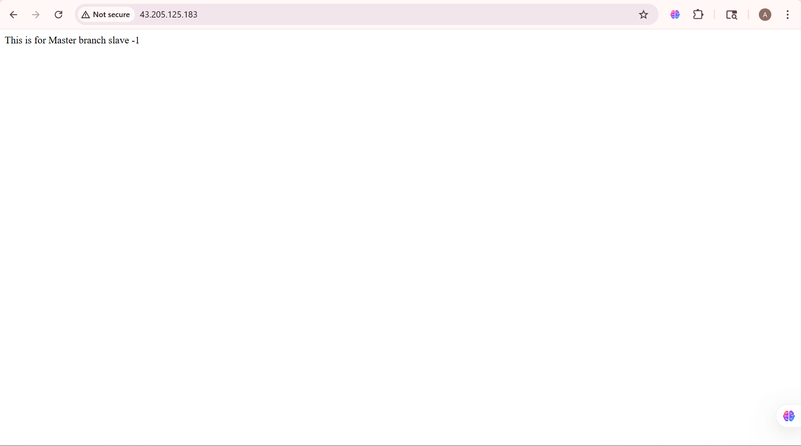

Job2:
Branch – 2026q1
Url: https://github.com/amitchandole05/Ass5-repo.git

Shell script:
cd /var/www/html
sudo rm -rf *
cd
cd /mnt/slave-2/workspace/Jenkins-Assignment-5-Job-2
sudo cp -r index.html /var/www/html
cd /var/www/html
sudo chmod 644 index.html
sudo service httpd start

Accessing the Website on Node -2

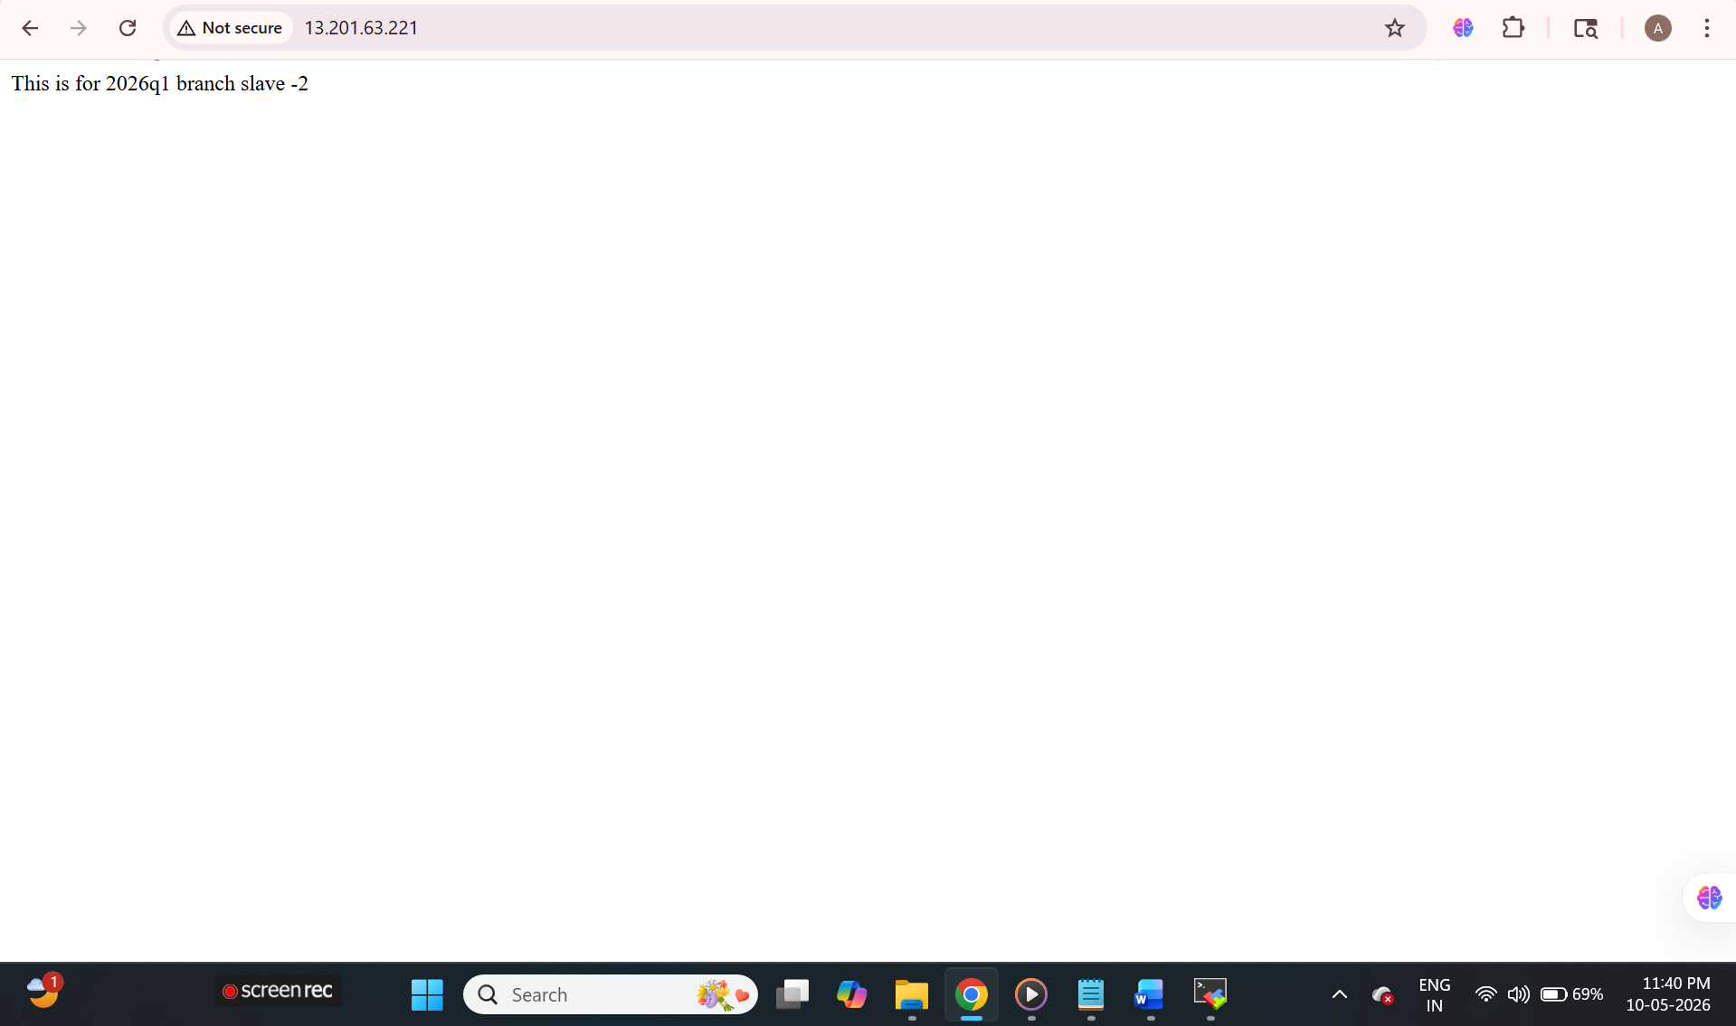

job3:
Branch – 2026q2
Repo - https://github.com/amitchandole05/Ass5-repo.git
Shell script:

cd /var/www/html
sudo rm -rf *
cd
cd /mnt/slave-3/workspace/Jenkins-Assignment-5-Job-3
sudo cp -r index.html /var/www/html
cd /var/www/html
sudo chmod 644 index.html
sudo service httpd start
Accessing the Website on Node -3

